**BCC Surplus Property Policy**

* All items that belong to the College (and by default, the state) must be disposed of according to the following protocols;
  + Reach out to BCC faculty/staff to see if there is a need for on-campus use.
  + Declare items to the state (process below).
  + Offer to non-profits in our community for a nominal fee – 80 days after step 1.
  + Schedule a Public Tag Sale – items for a nominal fee – 90 days after step 1.
  + After Tag Sale, offer to faculty/staff/students for personal use – no cost.
  + Salvage company for disposal.
* Once accepted, items are considered property of BCC, even if they were donated or purchased through grants.

**Massachusetts Operational Services Division Process**

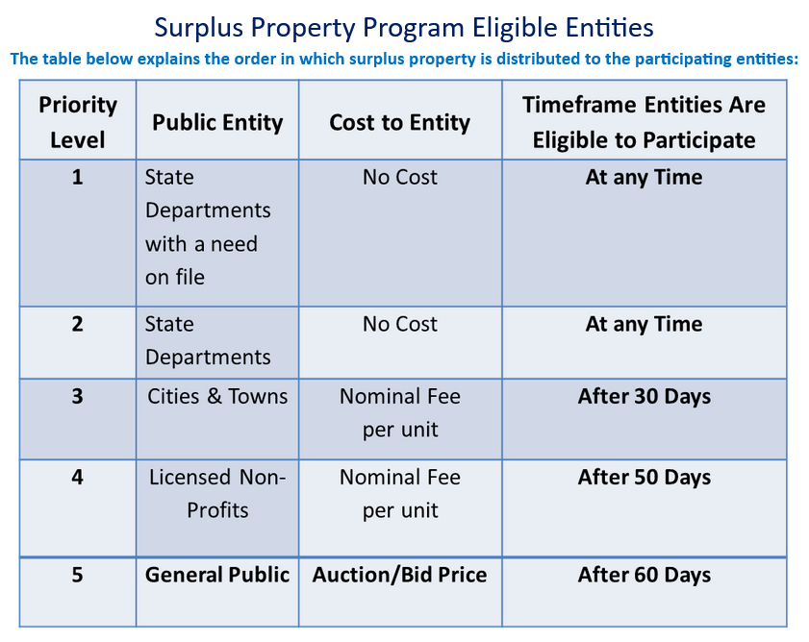

Source - <https://ma.recoup.promote.assetworks.com/promote/f?p=2109:4005>:::::: 9/14/23

* The Massachusetts State Surplus Property Office may request that large, or expensive items like vehicles, forklifts, etc. are channeled directly to their vendor-managed, on-line auction process.